**I. Import the dataset and do usual exploratory analysis steps like checking the**

**structure & characteristics of the dataset.**

1. Data type of all columns in the “customers” table.

**ANS:** 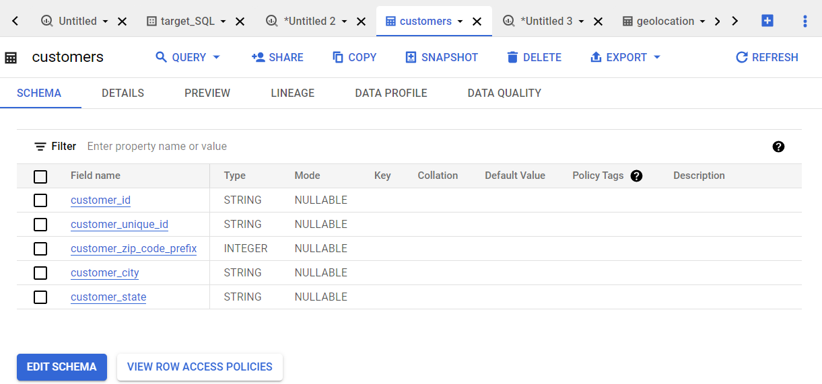

**Insights:** In the data type more string data types

1. Get the time range between which the orders were placed.

**ANS:**

SELECT min(order_purchase_timestamp) as frist_order,

max(order_purchase_timestamp) as last_order FROM `scalar-dsml-sql-raju.target_SQL.orders`



**Insights:** This market is opened for 2 years from 04/09/2016 and last order placed on 17/09/2018.

1. Count the number of Cities and States in our dataset.

**Ans:**  select count(distinct c.customer_city) cities ,count(distinct c.customer_state) states from `target_SQL.customers` c join `target_SQL.orders` o on c.customer_id=o.customer_id

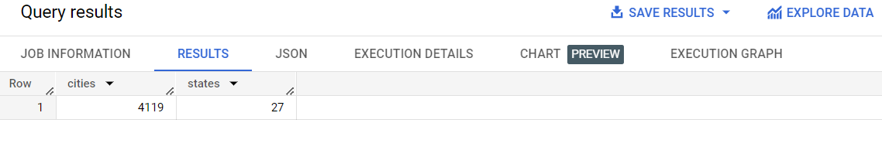

**Insights:** the total number of cities 4119 and 27 states.

**II. In-depth Exploration:**

1. Is there a growing trend in the no. of orders placed over the past years?

**ANS:**

select extract( month from order_purchase_timestamp) as month, extract(year from order_purchase_timestamp) as year,

count(*) as no_of_orders from `target_SQL.orders` group by month, year order by year asc, month asc

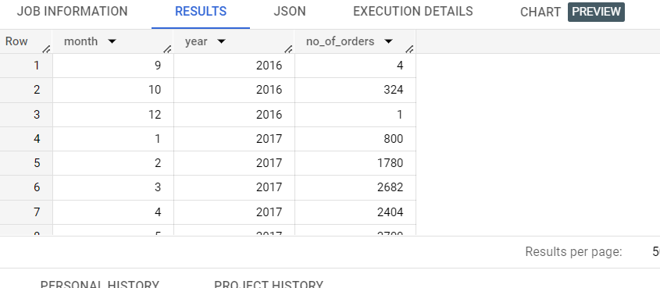

**Insights:** no. of orders in growing trend

**B.** Can we see some kind of monthly seasonality in terms of the no. of orders being

placed?

**Ans:** select extract(month from order_purchase_timestamp) as month, count(*) as no_of_orders from `target_SQL.orders`

group by month order by month

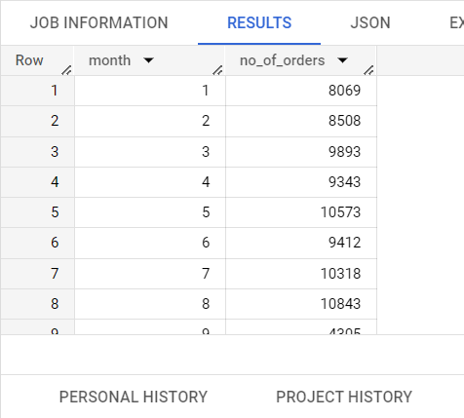

**Insights:**  7,8 months are peaked in no.of orders placed

**C.** During what time of the day, do the Brazilian customers mostly place their

orders? (Dawn, Morning, Afternoon or Night)

● 0-6 hrs : Dawn

● 7-12 hrs : Mornings

● 13-18 hrs : Afternoon

● 19-23 hrs : Night

**ANS:**

select case

when extract(hour from order_purchase_timestamp) between 0 and 6 then 'Dawn'

when extract(hour from order_purchase_timestamp) between 7 and 12 then 'Morning'

when extract(hour from order_purchase_timestamp) between 13 and 18 then 'Afternoon'

when extract(hour from order_purchase_timestamp) between 19 and 23 then 'Night' end as season,

count(*) as no_of_orders from `target_SQL.orders` group by season order by no_of_orders desc

limit 1

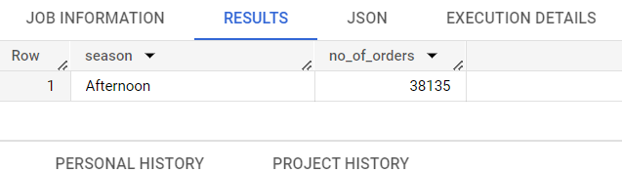

**Insight:**  afternoon is the most placed orders

______________________________________________________________________________

**III. Evolution of E-commerce orders in the Brazil region:**

1. Get the month on month no. of orders placed in each state.

**Ans:** select c.customer_state,extract(month from order_purchase_timestamp) as month,count(*) as no_of_orders from `target_SQL.customers` c join `target_SQL.orders` o on c.customer_id=o.customer_id group by 1,2 order by 1,2

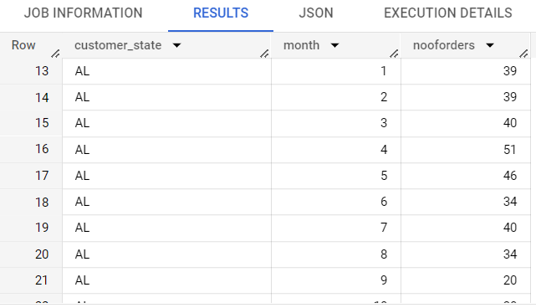

1. How are the customers distributed across all the states?

**Ans:** select customer_state ,count(*) as no_of_customers from `target_SQL.customers` group by 1 order by 1,2

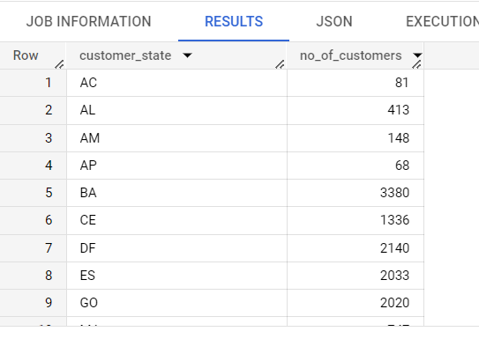

______________________________________________________________________________

**IV. Impact on Economy: Analyze the money movement by e-commerce by looking at**

**order prices, freight and others.**

**A.** Get the % increase in the cost of orders from year 2017 to 2018 *(include*

*months between Jan to Aug only).*

**Ans:** select ((lag_value-cost_of_orders)/lag_value )* 100 increase_percentage from (select year,cost_of_orders,lag(cost_of_orders) over (order by year desc) lag_value, from (select extract ( year from order_purchase_timestamp) as year,sum(payment_value) as cost_of_orders from `target_SQL.orders` o join `target_SQL.payments` p on o.order_id=p.order_id where extract ( year from order_purchase_timestamp) in (2017,2018) and extract ( month from order_purchase_timestamp) in (1,2,3,4,5,6,7,8) group by 1

) sub)anothersub order by 1 desc limit 1

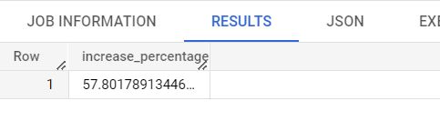

1. Calculate the Total & Average value of order price for each state.

**Ans:** select c.customer_state,sum(price) as total ,Avg(price) as Average from `target_SQL.customers` c join `target_SQL.orders` o on o.customer_id=c.customer_id join `target_SQL.order_items`as oi on oi.order_id=o.order_id group by 1

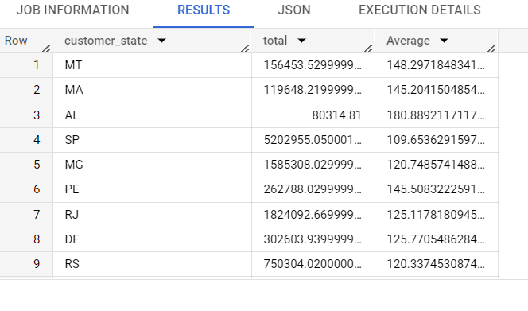

1. Calculate the Total & Average value of order freight for each state.

**Ans:** select c.customer_state,sum(freight_value) as total ,Avg(freight_value) as Average from `target_SQL.customers` c join `target_SQL.orders` o on o.customer_id=c.customer_id join `target_SQL.order_items`as oi on oi.order_id=o.order_id group by 1

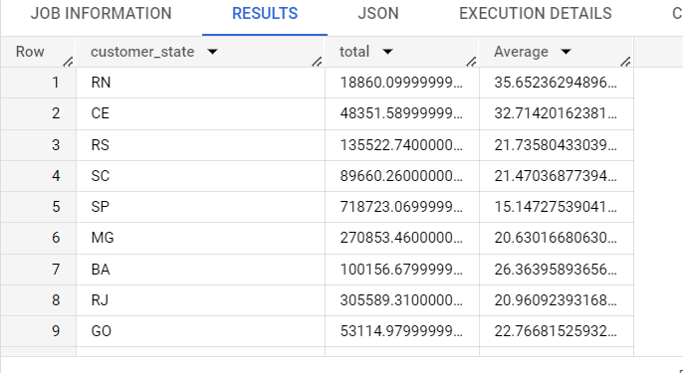

**V. Analysis based on sales, freight and delivery time.**

**A.** Find the no. of days taken to deliver each order from the order’s purchase date

as delivery time.

Also, calculate the difference (in days) between the estimated & actual delivery

date of an order.

Do this in a single query.

**Ans:** select order_id, ceil(timestamp_diff(order_delivered_customer_date, order_purchase_timestamp, hour)/24) as time_to_delivered,

ceil(timestamp_diff(order_estimated_delivery_date, order_delivered_customer_date, hour)/24) as diff_estimated_delivery from

`target_SQL.orders` order by time_to_delivered

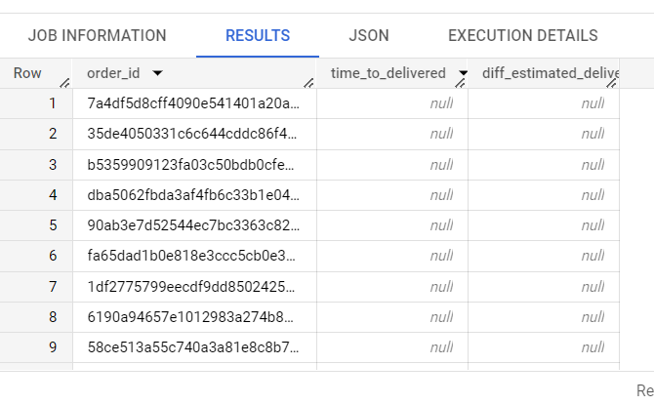

**B.** Find out the top 5 states with the highest & lowest average freight value.

select c.customer_state,avg(freight_value) as highest_average from `target_SQL.customers` c join `target_SQL.orders` o on o.customer_id=c.customer_id join `target_SQL.order_items`as oi

on oi.order_id=o.order_id group by 1 order by 2 desc limit 5

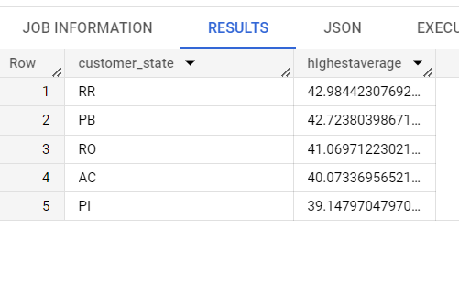

select c.customer_state,avg(freight_value) as lowest_average from `target_SQL.customers` c join `target_SQL.orders` o on o.customer_id=c.customer_id join `target_SQL.order_items`as oi

on oi.order_id=o.order_id group by 1 order by 2 asc  limit 5

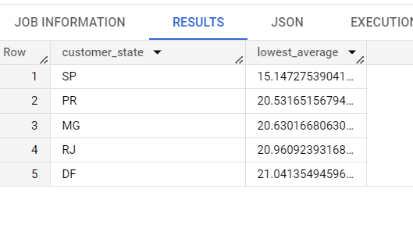

1. Find out the top 5 states with the highest & lowest average delivery time.

**ANS:**

select c.customer_state,avg(ceil(timestamp_diff(order_estimated_delivery_date,order_delivered_customer_date ,hour)/24)) as highest_average from `target_SQL.customers` c join `target_SQL.orders` o on o.customer_id=c.customer_id join `target_SQL.order_items`as oi on oi.order_id=o.order_id group by 1 order by 2 desc limit 5

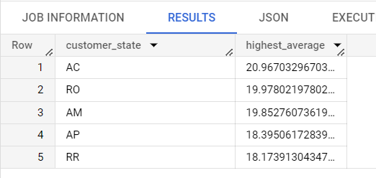

select c.customer_state,avg(ceil(timestamp_diff(order_estimated_delivery_date,order_delivered_customer_date ,hour)/24)) as lowest_average from `target_SQL.customers` c join `target_SQL.orders` o on o.customer_id=c.customer_id join `target_SQL.order_items`as oi on oi.order_id=o.order_id group by 1 order by 2 asc limit 5

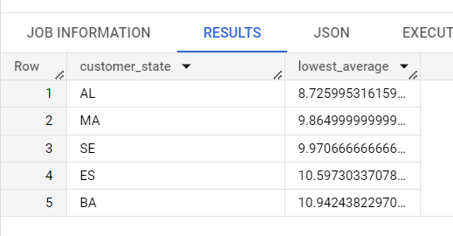

**D.** Find out the top 5 states where the order delivery is really fast as compared to

the estimated date of delivery.

**ANS:** select customer_state, avg(timestamp_diff(order_estimated_delivery_date, order_delivered_customer_date, hour)) as A_V from `target_SQL.orders` o join `target_SQL.customers` c on c.customer_id = o.customer_id group by 1

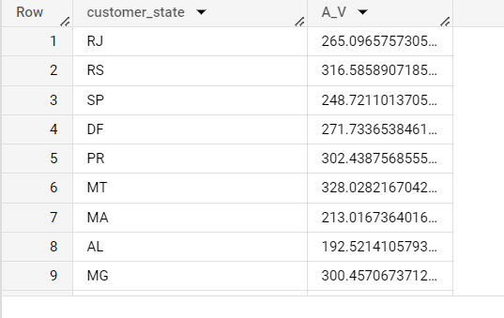

______________________________________________________________________________

**VI. Analysis based on the payments:**

1. Find the month on month no. of orders placed using different payment types**.**

**ANS:**

select payment_type, extract(month from order_purchase_timestamp ) as month, count(*) as no_of_orders from `target_SQL.payments` p join `target_SQL.orders` o on o.order_id=p.order_id group by 1,2 order by 2,1

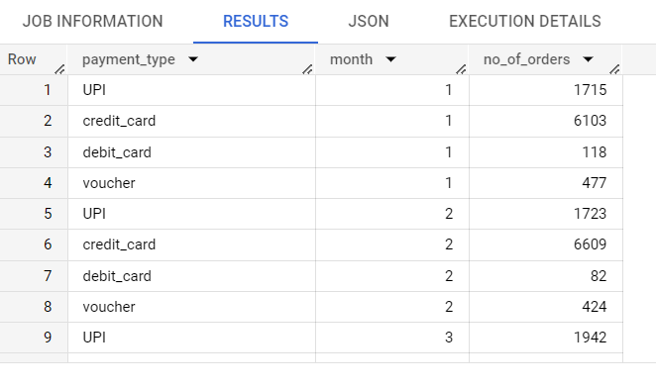

**B.** Find the no. of orders placed on the basis of the payment installments that have

been paid.

**ANS:**

select count(distinct(order_id)) as installments from `target_SQL.payments` where payment_installments>0

